SYSTEM REQUIREMENT SPECIFICATION

OBJECTIVE:
The main objective of the proposed solution is to be automated the various functions and activities of the bank through Internet. The solution will facilitate to the bank employees and the account holders with the different modules. This solution is very much necessary for the private sector banks and the corporate sector. The banking industry will take a new shape and explore like never before. Using the solution the bankers and account holders can generate various kinds of reports.

EXISTING SYSTEM

- It automates information related to particular bank.
- Complexity in management transactions.
- Loans details, card details, account main not maintain properly.
- Customer details may not maintain properly.
- Customer may not maintain all type of transaction details.

PROPOSED SYSTEM AND ITS MARIT
The development of this new system contains the following activities, which try to automate the entire process keeping in the view of database integration approach.
- Automates information related bank.
- It is easy process.
- Rich user interface.
- Customer can maintain all his personal details.
- Customer can maintain loan details, all transaction details.

Modules:
This application consists following modules:

- Admin module
- User module
- Bill payment Module
- Reports Module

1. Admin Module:
This module is belongs to bank staff. By using this module Administrator can add type of accounts (saving and current etc), minimum deposit amount in that particular account, interest rate and period of time.

- User Module:

This module is all about customers of a bank. By using this module customers can go for different operations like they can apply for a new account in a bank, they can apply for different loans based on their requirement and also they can view their personal information, modify both personal and login information etc. Following operations can be done by any customer.
  - New Account: Customer can open a new account.
  - Teller Services: Customer can apply for a new debit card
  - Transaction Details: Customer can transfer his funds to other accounts and also they can pay tax to govt.
  - Requests: By using this functionality customer can go for different type of transactions on drafts and cheque(s).
  - Maintenance Services: Either customers can close their accounts or they can modify their information.
  - User Alerts: Customer can pay credit card amount to that bank.

3. Bill Payment Services:
Customer can pay bills like electricity bill, telephone bill etc through his account.

4. Reports Module:
In this module administrator will get different types of reports regarding customers like Number of customers of this portal etc. And this module is controlled by administrator only.

- Accounts
- Card Transactions
- Cheque reorder
- Credit cards
- Customers
- Draft cheque
- Funds Transfer
- Nominee Details
- Tax Payments
- Bill Payments

Software requirements:

Operating System : Windows
Technology : Java/j2ee (JDBC, Servlets, JSP)
Web Technologies : Html, JavaScript, CSS
IDE : My Eclipse
Web Server : Tomcat
Database : Oracle
Software’s : J2SDK1.5, Tomcat 5.5, Oracle 9i

Hardware requirements:

Hardware : Pentium based systems with a minimum of p4
RAM : 256MB (minimum)

FEASIBILITY STUDY

FEASIBILITY REPORT
TECHNICAL FEASIBILITY:
Evaluating the technical feasibility is the trickiest part of a feasibility study. This is because, at this point in time, not too many detailed design of the system, making it difficult to access issues like performance, costs on (on account of the kind of technology to be deployed) etc. A number of issues have to be considered while doing a technical
analysis.
- Understand the different technologies involved in the proposed system:
Before commencing the project, we have to be very clear about what are the technologies that are to be required for the development of the new system.
- Find out whether the organization currently possesses the required technologies:
  - Is the required technology available with the organization?
  - If so is the capacity sufficient?
For instance –
“Will the current printer be able to handle the new reports and forms required for the new system?”

OPERATIONAL FEASIBILITY:
Proposed projects are beneficial only if they can be turned into information systems that will meet the organizations operating requirements. Simply stated, this test of feasibility asks if the system will work when it is developed and installed. Are there major barriers to Implementation? Here are questions that will help test the operational feasibility of a project:
- Is there sufficient support for the project from management from users? If the current system is well liked and used to the extent that persons will not be able to see reasons for change, there may be resistance.
- Are the current business methods acceptable to the user? If they are not, Users may welcome a change that will bring about a more operational and useful systems.
- Have the user been involved in the planning and development of the project?
- Early involvement reduces the chances of resistance to the system and in
- General and increases the likelihood of successful project.
Since the proposed system was to help reduce the hardships encountered. In the existing manual system, the new system was considered to be operational feasible.
ECONOMIC FEASIBILITY:
Economic feasibility attempts 2 weigh the costs of developing and implementing a new system, against the benefits that would accrue from having the new system in place. This feasibility study gives the top management the economic justification for the new system.
A simple economic analysis which gives the actual comparison of costs and benefits are much more meaningful in this case. In addition, this proves to be a useful point of reference to compare actual costs as the project progresses. There could be various types of intangible benefits on account of automation. These could include increased customer satisfaction, improvement in product quality better decision making timeliness of information, expediting activities, improved accuracy of operations, better documentation and record keeping, faster retrieval of information, better employee morale.

PROCESS FLOW

ARCHITECTURE DIAGRAM

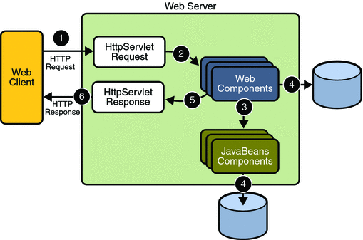

SDLC METHDOLOGIES

This document play a vital role in the development of life cycle (SDLC) as it describes the complete requirement of the system. It means for use by developers and will be the basic during testing phase. Any changes made to the requirements in the future will have to go through formal change approval process.
SPIRAL MODEL was defined by Barry Boehm in his 1988 article, “A spiral Model of Software Development and Enhancement. This model was not the first model to discuss iterative development, but it was the first model to explain why the iteration models.
As originally envisioned, the iterations were typically 6 months to 2 years long. Each phase starts with a design goal and ends with a client reviewing the progress thus far. Analysis and engineering efforts are applied at each phase of the project, with an eye toward the end goal of the project.
The steps for Spiral Model can be generalized as follows:
- The new system requirements are defined in as much details as possible. This usually involves interviewing a number of users representing all the external or internal users and other aspects of the existing system.
- A preliminary design is created for the new system.
- A first prototype of the new system is constructed from the preliminary design. This is usually a scaled-down system, and represents an approximation of the characteristics of the final product.
- A second prototype is evolved by a fourfold procedure:
- Evaluating the first prototype in terms of its strengths, weakness, and risks.
- Defining the requirements of the second prototype.
- Planning an designing the second prototype.
- Constructing and testing the second prototype.
- At the customer option, the entire project can be aborted if the risk is deemed too great. Risk factors might involved development cost overruns, operating-cost miscalculation, or any other factor that could, in the customer’s judgment, result in a less-than-satisfactory final product.
- The existing prototype is evaluated in the same manner as was the previous prototype, and if necessary, another prototype is developed from it according to the fourfold procedure outlined above.
- The preceding steps are iterated until the customer is satisfied that the refined prototype represents the final product desired.
- The final system is constructed, based on the refined prototype.
- The final system is thoroughly evaluated and tested. Routine maintenance is carried on a continuing basis to prevent large scale failures and to minimize down time.

The following diagram shows how a spiral model acts like:

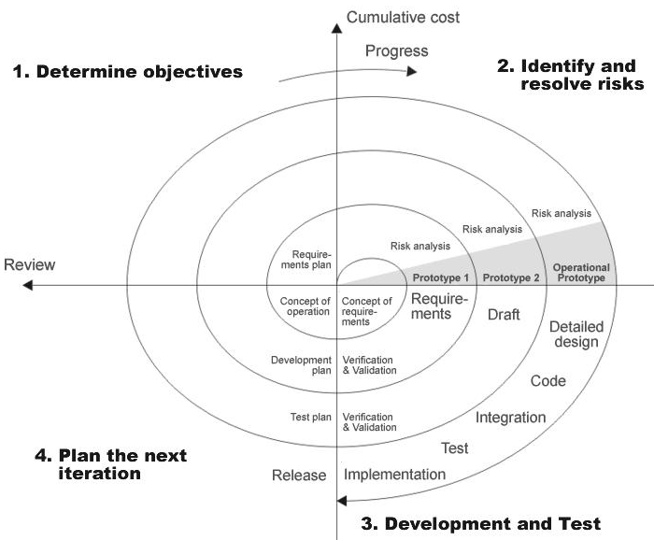

Fig 1.0-Spiral Model

ADVANTAGES
- Estimates(i.e. budget, schedule etc .) become more relistic as work progresses, because important issues discoved earlier.
- It is more able to cope with the changes that are software development generally entails.
- Software engineers can get their hands in and start woring on the core of a project earlier.

APPLICATION DEVELOPMENT

N-TIER APPLICATIONS
N-Tier Applications can easily implement the concepts of Distributed Application Design and Architecture. The N-Tier Applications provide strategic benefits to Enterprise Solutions. While 2-tier, client-server can help us create quick and easy solutions and may be used for Rapid Prototyping, they can easily become a maintenance and security night mare
The N-tier Applications provide specific advantages that are vital to the business continuity of the enterprise. Typical features of a real life n-tier may include the following:
- Security
- Availability and Scalability
- Manageability
- Easy Maintenance
- Data Abstraction
The above mentioned points are some of the key design goals of a successful n-tier application that intends to provide a good Business Solution.

DEFINITION
Simply stated, an n-tier application helps us distribute the overall functionality into various tiers or layers:
- Presentation Layer
- Business Rules Layer
- Data Access Layer
- Database/Data Store
Each layer can be developed independently of the other provided that it adheres to the standards and communicates with the other layers as per the specifications.
This is the one of the biggest advantages of the n-tier application. Each layer can potentially treat the other layer as a ‘Block-Box’.
In other words, each layer does not care how other layer processes the data as long as it sends the right data in a correct format.

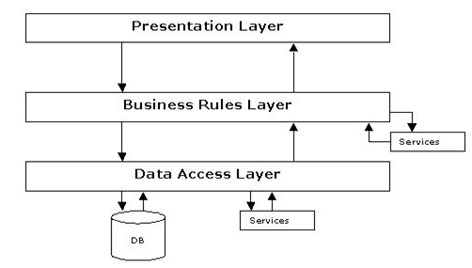
Fig 1.1-N-Tier Architecture

- THE PRESENTATION LAYER
Also called as the client layer comprises of components that are dedicated to presenting the data to the user. For example: Windows/Web Forms and buttons, edit boxes, Text boxes, labels, grids, etc.
- THE BUSINESS RULES LAYER
This layer encapsulates the Business rules or the business logic of the encapsulations. To have a separate layer for business logic is of a great advantage. This is because any changes in Business Rules can be easily handled in this layer. As long as the interface between the layers remains the same, any changes to the functionality/processing logic in this layer can be made without impacting the others. A lot of client-server apps failed to implement successfully as changing the business logic was a painful process.

- THE DATA ACCESS LAYER
This layer comprises of components that help in accessing the Database. If used in the right way, this layer provides a level of abstraction for the database structures. Simply put changes made to the database, tables, etc do not affect the rest of the application because of the Data Access layer. The different application layers send the data requests to this layer and receive the response from this layer.
- THE DATABASE LAYER
This layer comprises of the Database Components such as DB Files, Tables, Views, etc. The Actual database could be created using SQL Server, Oracle, Flat files, etc.
In an n-tier application, the entire application can be implemented in such a way that it is independent of the actual Database. For instance, you could change the Database Location with minimal changes to Data Access Layer. The rest of the Application should remain unaffected.

